**Placement Management Portal using Full stack Web Development with Java**

**ABSTRACT**

The **Online Doctor's Appointment System** is a comprehensive full-stack web application developed to streamline and enhance the process of booking medical consultations for patients, doctors, and clinic administrators. Built using **Java (JSP)** for the backend, **SQL** for database management, and integrated with modern frontend technologies **HTML5** and **CSS3**, the platform offers a user-friendly interface and efficient functionality. It facilitates seamless appointment scheduling, doctor availability tracking, and administrative oversight, ultimately contributing to the digital transformation of healthcare services.

The project was developed as a group effort by –

**RIYA MEHTA (001CSE22GT022)** , **AYUSH KUMAR PANDEY (001CSE22GT003)** and **MRINAL KANT SHIT(001CSE22GT018)**, under the valuable mentorship of **Mr**. **Shashi Kumar Tanti Sir**.

The primary objective of the **Online Doctor's Appointment System** is to automate and manage various aspects of the medical consultation process, including patient registration, doctor listings, appointment scheduling, availability tracking, and consultation history management. The system ensures secure login for different user roles—patients, doctors, and administrators—each with customized functionalities. The backend is powered by robust **Java-based frameworks (JSP/Servlets)**, ensuring data consistency, security, and performance, while the frontend offers a responsive and user-friendly interface using **HTML5** and **CSS3**.

This project not only addresses the limitations of traditional appointment booking methods but also offers a scalable and maintainable solution for healthcare service providers. It reflects the collaborative effort and practical implementation of full-stack web development skills, effective project management, and real-world problem-solving abilities.

**Acknowledgement**

We would like to express our sincere gratitude to everyone who contributed to the successful completion of our project titled **"ONLINE DOCTOR’S APPOINTMENT WEBSITE"** developed using full-stack web technologies including **Java (JSP),** and **SQL database**.

First and foremost, we are deeply thankful to our mentor, **Mr** **Shashi Kumar Tanti Sir**, for his invaluable guidance, continuous support, and encouragement throughout the development of this project. His technical expertise and constructive feedback played a crucial role in shaping our understanding and refining our implementation.

We also extend our appreciation to our institution and faculty members for providing the necessary resources and a conducive environment for learning and development.

This project was a collaborative effort, and we, **Riya Mehta**, **Ayush Kumar Pandey**, and **Mrinal Kanti Shit**, are grateful to each other for the strong teamwork, dedication, and effort put in at every stage—from initial planning to final deployment.

Lastly, we thank our families and friends for their constant support and motivation, which inspired us to give our best.

* **AYUSH KUMAR PANDEY**

**B.Tech(C.S.E)**

**Semester – VI**

**(001CSE22GT003)**

**Table of Contents**

1. Introduction …………………………………………………………….. 4

2. Chapter 1 – Introduction to HTML …………………………………….. 5

2.1About HTML

2.2Some basic codes in HTML ………………………………………….

* 1. Marquee Tag in Html

2.4Tables and Forms in Html

1. Chapter 2 – Introduction to JSP

3.1About JSP …………………………………………………………..

* 1. First Program in JSP ……………………………………
  2. Linking html forms with jsp page ……………………….

1. Chapter 3 – SQL

4.1Installing SQL 10g……………………………………

4.2Connecting to Database …………………………………..

* 1. Basics queries of SQL …………………………………..

1. Chapter 4 – About Apache Tomcat Server

5.1Installation and Running of Apache Tomcat…………………………..

* 1. Hosting our first webpage on local server 8080……………………….

1. Chapter 5 – Developing our Group Project

6.1 Creating Frontend ………………………………………..

6.2 Creating Tables in Database ……………………………………..

6.3 Creating JSP pages for connectivity…….

6.4 Final output

1. References

**Introduction**

In today’s fast-paced and digitally driven world, accessing healthcare in a timely and organized manner is essential. Traditional methods of booking doctor appointments—such as in-person visits or phone calls—are often time-consuming, inefficient, and prone to scheduling errors. This not only affects patient satisfaction but also places an unnecessary administrative burden on healthcare providers.

To address these challenges, we have developed an **Online Doctor's Appointment System** — a web-based application designed to streamline and automate the process of booking medical consultations. This system provides a centralized digital platform where patients can book appointments, doctors can manage their schedules, and administrators can oversee operations with ease and efficiency.

The application is built using **Java JSP and Servlets** for the server-side logic and dynamic content generation, ensuring a robust and scalable backend. For data storage and retrieval, **SQL** is used to create and manage a structured database that efficiently handles user accounts, appointment records, doctor schedules, and consultation histories. The user interface is crafted using **HTML5** and **CSS3** to deliver a clean, intuitive, and responsive experience across all user roles—patient, doctor, and administrator.

**Key functionalities of the Online Doctor's Appointment System include:**  
• **Patient Module**: Registration, login, profile management, doctor browsing by specialization, appointment booking, and consultation history.  
• **Doctor Module**: Profile management, schedule setup, appointment viewing, and status updates.  
• **Admin Module**: Verification of patient and doctor accounts, system monitoring, and report generation.

The **Online Doctor's Appointment System** not only enhances the accessibility and efficiency of healthcare services but also lays a scalable foundation for future integration with features like automated SMS/email reminders, teleconsultation support, electronic prescriptions, and real-time availability tracking.

Through this project, we aimed to leverage full-stack web development to create a reliable, user-friendly, and effective solution for modern healthcare appointment management.

**Chapter 1 – Introduction to HTML**

**1.1 About Html**

**HTML** stands for **HyperText Markup Language**. It is the standard language used to create and structure content on the **World Wide Web**. HTML provides the basic building blocks for web pages, allowing developers to define elements like headings, paragraphs, links, images, tables, forms, and more.

**What is HTML?**

HTML is not a programming language; it is a **markup language**. This means it is used to "mark up" text and other content to tell a web browser how to display it. It consists of **elements** or **tags**, which are enclosed in angle brackets like <tagname>...</tagname>.

**Basic Structure of a HTML Document**

**<!DOCTYPE html>**

**<html>**

**<head>**

**<title>My First Web Page</title>**

**</head>**

**<body>**

**<h1>Welcome to HTML!</h1>**

**<p>This is a simple paragraph.</p>**

**</body>**

**</html>**

**Key Components:**

* <!DOCTYPE html>: Declares the document type and version of HTML.
* <html>: The root element of an HTML page.
* <head>: Contains metadata, such as the page title, links to stylesheets, etc.
* <title>: Sets the title shown in the browser tab.
* <body>: Contains the content that is displayed on the webpage, such as text, images, and links.
* <h1> to <h6>: Headings of different levels.
* <p>: Paragraph tag used for blocks of text.

2.2 Some basic codes in HTML

<html>

<body>

Hello <br>

World <hr>

<p align="left">Raja</p>

<p align = "right">Harsh</p>

<p align = "center">Riya</p>

<h1>Ram</h1>

<h2>Shyam</h2>

<h3>Raghav</h3>

<h4>Ram</h4>

<h5>Shyam</h5>

<h6>Raghav</h6>

<font face="chiller" size="+7" color="red">Welcome</font>

<img src="a.jpg" border = 1 height=300 width=300 alt="flower">

<a href="a.html">click</a>

<a href="a.html" target ="_self">click</a>

<a href="a.html" target ="_blank">click</a>

<a href="http:www.google.com"><img src="ab.jpg" height=100 width = 100 ></a>

<table border=1>

<tr><th>Roll</th><th>Name</th></tr>

<tr><td>1</td><td>Mangru</td></tr>

</table>

</body>

</html>

**2.3 Marquee Tag in HTML**

<html>

<body>

<marquee>welcome</marquee>

<marquee direction="left">LEFT</marquee>

<marquee direction="right">RIGHT</marquee>

<marquee direction="up">UP</marquee>

<marquee direction="down">DOWN</marquee>

<marquee behavior="scroll">SCROLL</marquee>

<marquee behavior="alternate">ALTERNATE</marquee>

<marquee behavior="slide">SLIDE</marquee>

<marquee bgcolor="yellow" direction=right scrolldelay="300">welcome to my college</marquee>

</body>

</html>

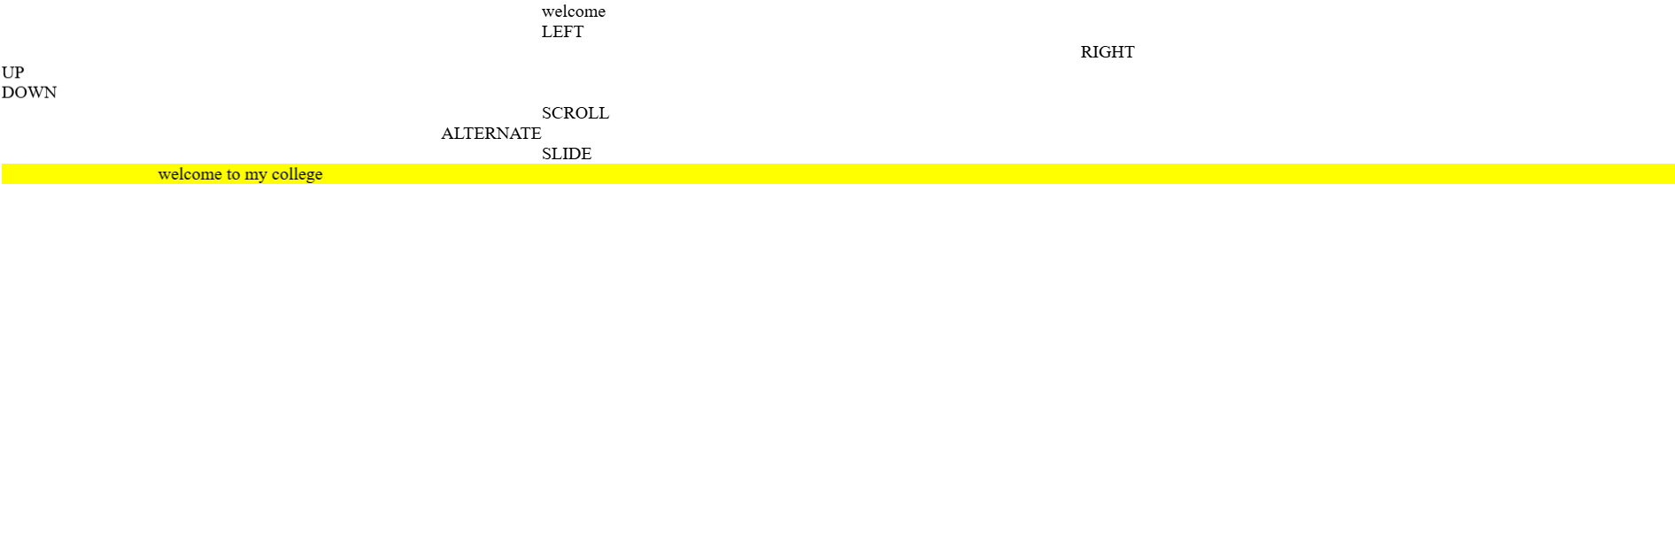

**2.4 Table and Forms in Html**

**Forms :**

<html>

<body>

<h1>HTML FORMS</h1>

<form name="frm">

NAME<input type="text" name="nm" size="20"> <br><br><br>

PASSWORD<input type="password" name="pwd" size="20"> <br><br><br>

GENDER<input type="radio" name="rd" value="male">Male

<input type="radio" name="rd" value="female">Female

<br><br><br>

NEWSPAPER<input type="checkbox" name="c1" value="Telegraph">Telegraph

<input type="checkbox" name="c2" value="Times Of India">Times Of India

<input type="checkbox" name="c3" value="Pioneer">Pioneer

<input type="checkbox" name="c4" value="Hindustan Times">Hindustan Times

<br><br><br>

Country

<select name="con">

<option>India</option>

<option>Japan</option>

<option>Nepal</option>

<option>Bhutan</option>

<option>Bangladesh</option>

</select>

<br>

<br><br>

HOBBY

<select multiple=true>

<option>Cricket</option>

<option>Football</option>

<option>Hockey</option>

<option>Dance</option>

<option>Table Tennis</option>

</select>

<br>

<br><br>

ABOUT US

<textarea rows=6 cols=10>

</textarea>

<br><br><br>

phone number<input type="number" name="ph" size=20><br><br><br>

date of birth<input type="date" name="dt" ><br><br><br>

<input type="submit" value="submit">

</form>

</body>

</html>

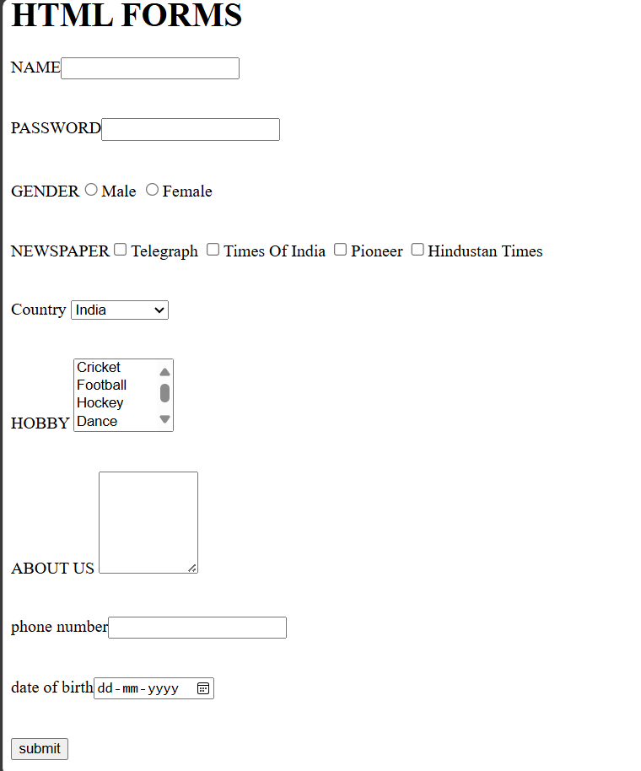

**Tables**

<html>

<body>

<h1>HTML Table</h1>

<form name="frm">

<table border=1 bgcolor=yellow cellspacing=5>

<tr><td>NAME</td><td>

<input type="text" name="nm" size="20"> </td></tr>

<tr><td>PASSWORD</td><td><input type="password" name="pwd" size="20"></td></tr>

<tr><td>GENDER</td><td><input type="radio" name="rd" value="male">Male

<input type="radio" name="rd" value="female">Female</td></tr>

<tr><td>NEWSPAPER</td><td><input type="checkbox" name="c1" value="Telegraph">Telegraph</td></tr>

<tr><td></td><td>

<input type="checkbox" name="c2" value="Times Of India">Times Of India</td></tr>

<tr><td></td><td><input type="checkbox" name="c3" value="Pioneer">Pioneer</td></tr>

<tr><td></td><td>

<input type="checkbox" name="c4" value="Hindustan Times">Hindustan Times</td></tr>

<tr><td>Country</td><td><select name="con">

<option>India</option>

<option>Japan</option>

<option>Nepal</option>

<option>Bhutan</option>

<option>Bangladesh</option>

</select></td></tr>

<tr><td>Hobby</td><td><select multiple=true>

<option>Cricket</option>

<option>Football</option>

<option>Hockey</option>

<option>Dance</option>

<option>Table Tennis</option>

</select></td></tr>

<tr><td>About Us</td><td><textarea rows=6 cols=10>

</textarea></td></tr>

</table>

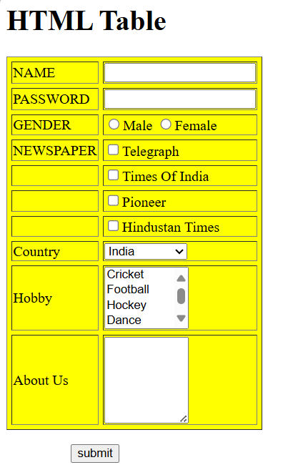</form>

&nbsp&nbsp&nbsp&nbsp&nbsp&nbsp&nbsp&nbsp&nbsp&nbsp&nbsp

&nbsp&nbsp&nbsp&nbsp&nbsp

</body>

</html>

3. Chapter 2 – Introduction to JSP

3.1 About JSP

**JSP (JavaServer Pages)** is a **server-side technology** used for creating **dynamic web content** using Java. Developed by Sun Microsystems (now part of Oracle), JSP is built on top of the Java Servlet technology and allows embedding Java code directly into HTML pages using special JSP tags.

**What is JSP?**

JSP files are text-based documents saved with a .jsp extension. They contain a mix of **HTML**, **Java code**, and **JSP-specific tags**, which are executed on the **server side** before the page is sent to the user's browser.

When a client requests a JSP page:

1. The web server passes the request to a **JSP engine**.
2. The engine converts the JSP into a **Servlet** (a Java class).
3. The Servlet is compiled and executed on the server.
4. The output (usually HTML) is sent to the browser.

**Why Use JSP?**

* **Separation of concerns**: JSP separates presentation (HTML) from business logic (Java).
* **Reusability**: JavaBeans and custom tags can be reused across pages.
* **Integration**: Easily integrates with Java-based technologies and databases.
* **Familiar Syntax**: Developers familiar with HTML and Java can learn JSP quickly.

**Basic Syntax Example:**

**<%@ page language="java" contentType="text/html" %>**

**<html>**

**<head><title>JSP Example</title></head>**

**<body>**

**<h1>Welcome to JSP!</h1>**

**<%**

**String name = "Arwin";**

**out.println("Hello, " + name + "!");**

**%>**

**</body>**

**</html>**

**Common JSP Tags:**

* <% %>: Scriptlet — contains Java code.
* <%= %>: Expression — outputs a value.
* <%@ %>: Directive — provides instructions (like importing packages).
* <jsp:include>: Includes content from another file.
* <jsp:useBean>: Uses a JavaBean in the page.

**3.2 First Program in JSP**

<%@ page language="java" contentType="text/html; charset=UTF-8" %>

<!DOCTYPE html>

<html>

<head>

<title>Hello World in JSP</title>

</head>

<body>

<h1>

<%-- JSP scriptlet to print Hello World --%>

<%

out.println("Hello, World!");

%>

</h1>

</body>

</html>

**3.2 Linking Html forms with JSP**

**Temperature .html**

HTML>

<BODY>

<CENTER> <h1> TEMPERATURE CONVERSION </h1> <BR>

<FORM METHOD="POST" ACTION="http://localhost:80/temp.jsp">

<h2>ENTER THE TEMPERATURE :

<INPUT TYPE="TEXT" NAME="temp">

<br>

SELECT THE CONVERSION TYPE : <br>

<INPUT TYPE="RADIO" NAME ="conv" VALUE="1">

1.CELSIUS TO FAHRENHEIT

<INPUT TYPE="RADIO" NAME="conv" VALUE="2">

2. FAHRENHEIT TO CELSIUS

</h2> <br> <INPUT TYPE="SUBMIT" VALUE="SUBMIT">

</FORM>

</BODY>

</HTML>

**Temperature.jsp**

HTML>

<BODY>

<CENTER><h1> TEMPERATURE CONVERSION </h1> <br> <br>

<% double Tc,Tf;

double t=Double.parseDouble(request.getParameter("temp"));

int type=Integer.parseInt(request.getParameter("conv"));

if(type==2)

{

Tc=0.55*(t-32);

%>

<P> <h2> <%=t%> Fahrenheit = <%=Tc%>' Celcius </h2>

<% }

else

{

Tf=(1.8*t)+32;

%>

<P> <h2> <%=t%>' Celcius = <%=Tf%> Fahrenheit </h2>

<% }

%>

</BODY>

</HTML>

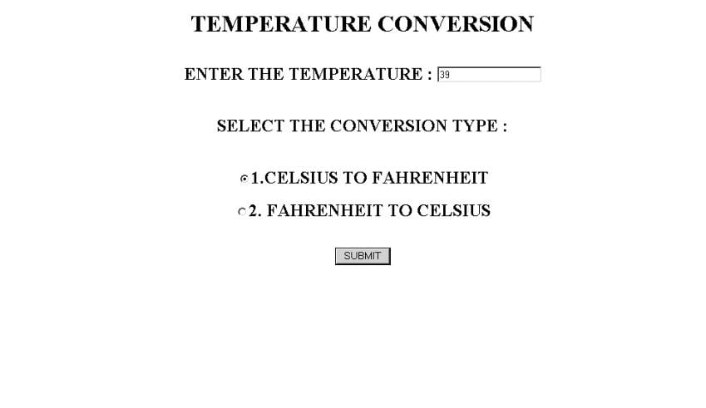



1. Chapter 3 – SQL
   1. Installing SQL 10g XE

#### ****Installation Steps****

1. **Extract the .zip/.rar** file if downloaded.
2. Run setup.exe as **Administrator**.
3. Choose **Basic Installation** or **Advanced Installation**.
4. Set:
   * **Oracle Home**: Installation directory
   * **Global Database Name**: e.g., orcl
   * **Password**: Remember this for SQL login
5. Follow prompts and let the installation complete.

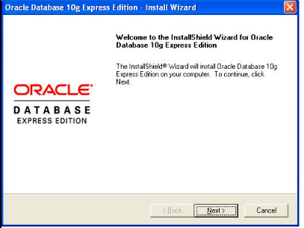

#### 

* 1. **Connecting to Database :**

#### ****After Installation****

* Launch **SQL*Plus** from Start Menu or Desktop
* Login using: Username: system
* Password: [your password]

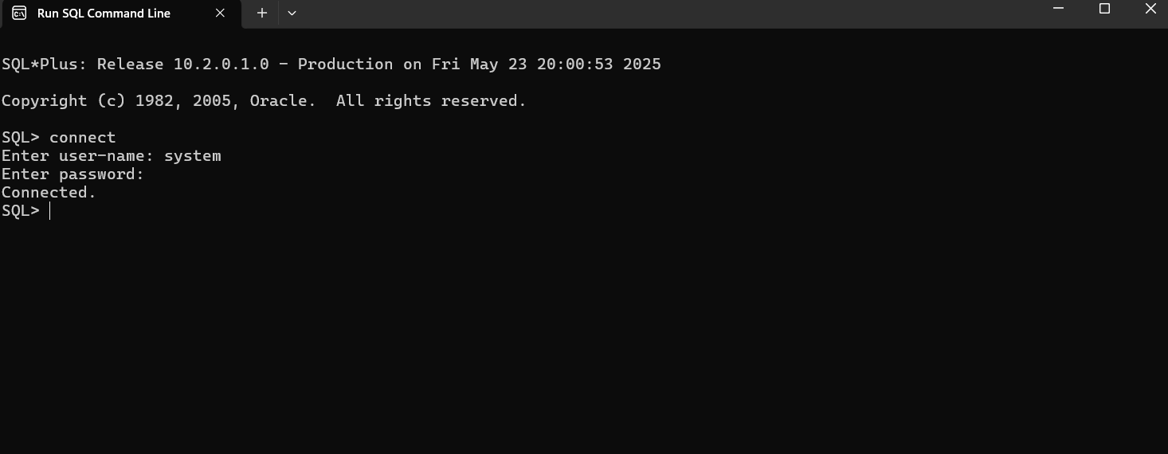

* 1. **Basic Queries of SQL**

**Creating a table**

CREATE TABLE Students (

ID INT PRIMARY KEY,

Name VARCHAR(50),

Age INT,

Department VARCHAR(50)

);

**Inserting into table :**

INSERT INTO Students (ID, Name, Age, Department)

VALUES (1, 'ABC', 21, 'CSE');

**Selecting all values:**

SELECT * FROM Students;

**Use where Clause:**

SELECT * FROM Students

WHERE Department = 'CSE';

**Update Data :**

UPDATE Students

SET Age = 22

WHERE ID = 1;

**Delete a Record:**

DELETE FROM Students

WHERE ID = 1;

1. Chapter 4 - About Apache Tomcat Server

Apache Tomcat is an open-source web server and servlet container developed by the Apache Software Foundation. It primarily supports Java-based web applications by executing Java Servlets and rendering JSP (JavaServer Pages). Tomcat is lightweight, efficient, and widely used for hosting dynamic websites and applications, making it a popular choice for Java developers.

* 1. **Installation and Running of Apache Tomcat**

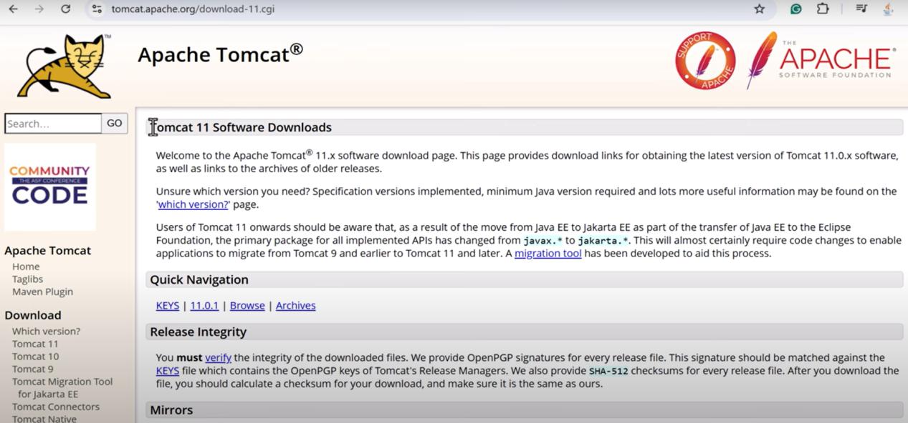Step 1 : Go to the official Apache Tomcat website and download the latest stable version of Tomcat for your operating system.

Step 2 : Unzip the file and click on install and set username and password

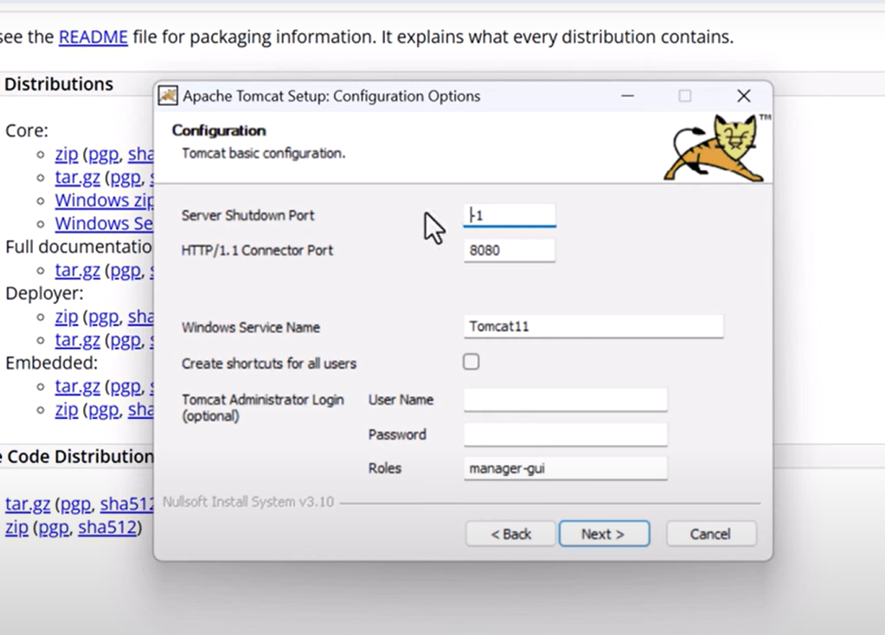

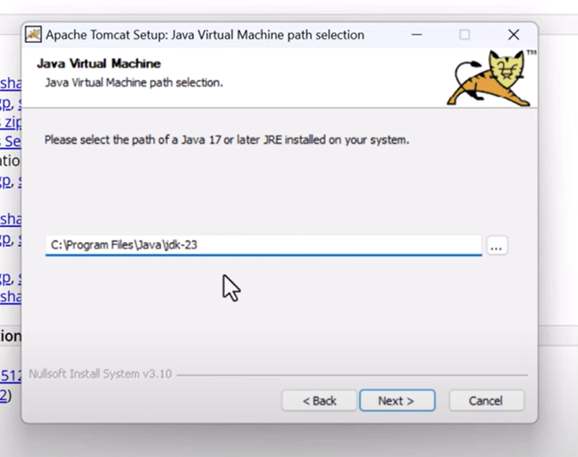Step 3: Select jdk

**Running Apache Tomcat Server**

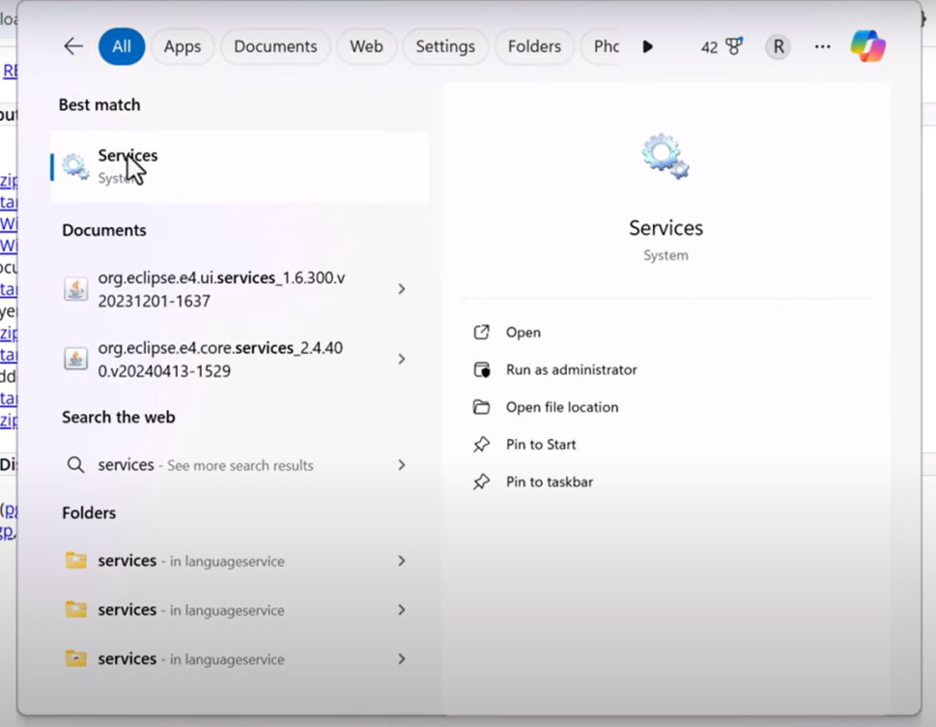 Step 1 : Click on services

Step 2 : Right click and click on “start” server

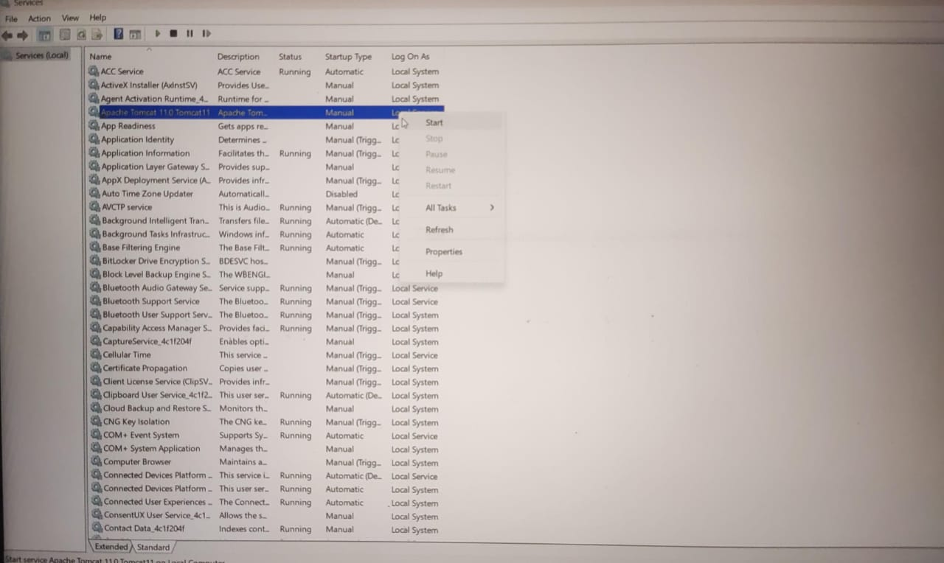

**Verifying if Apache Tomcat Server is running or not**

* Go to google and type “localhost:8080”
* If you see welcome page then you have successfully run the Tomcat Server

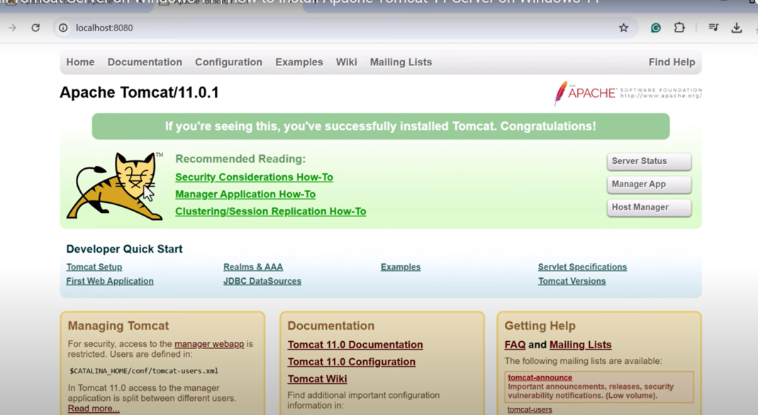

* 1. **Hosting our first webpage on Tomcat server**

Step 1 : Start the Tomcat server

Step 2 : Go to welcome page of Tomcat server through the Apache tomcat folder

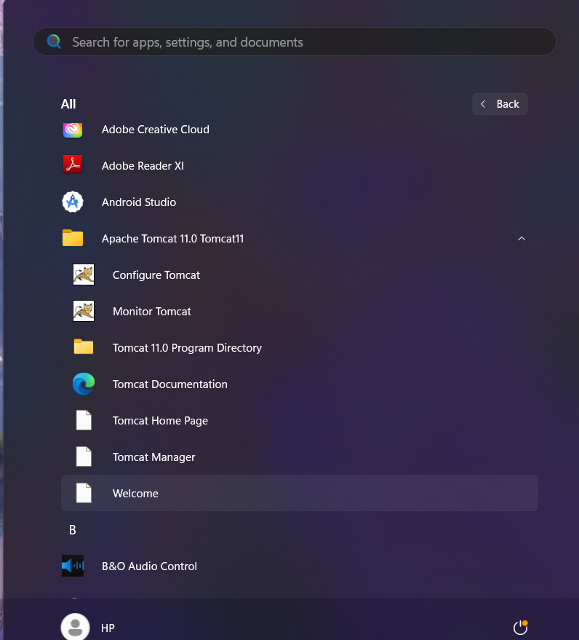

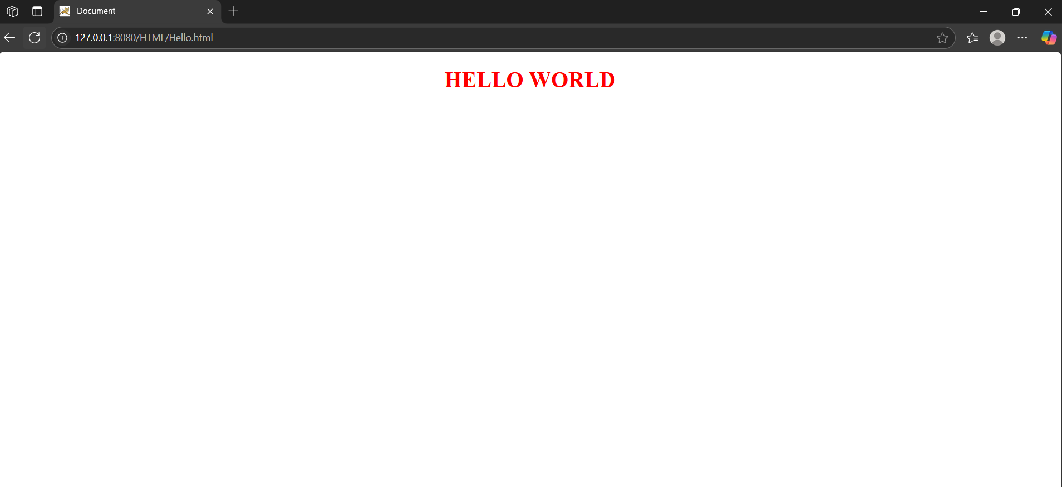Step 3: Write the webpage folder path in the server’s search bar :

6 . Chapter 5 – Developing our Group Project

**6.1 Creating Front End**

Homepage(FRONT.html)

<!DOCTYPE html>

<HTML>

<HEAD>

<style>

.button-33 {

background-color: #c2fbd7;

border-radius: 100px;

box-shadow: rgba(44, 187, 99, .2) 0 -25px 18px -14px inset,rgba(44, 187, 99, .15) 0 1px 2px,rgba(44, 187, 99, .15) 0 2px 4px,rgba(44, 187, 99, .15) 0 4px 8px,rgba(44, 187, 99, .15) 0 8px 16px,rgba(44, 187, 99, .15) 0 16px 32px;

color: green;

cursor: pointer;

display: inline-block;

font-family: CerebriSans-Regular,-apple-system,system-ui,Roboto,sans-serif;

padding: 7px 20px;

text-align: center;

text-decoration: none;

transition: all 250ms;

border: 0;

font-size: 16px;

user-select: none;

-webkit-user-select: none;

touch-action: manipulation;

}

.button-33:hover {

box-shadow: rgba(44,187,99,.35) 0 -25px 18px -14px inset,rgba(44,187,99,.25) 0 1px 2px,rgba(44,187,99,.25) 0 2px 4px,rgba(44,187,99,.25) 0 4px 8px,rgba(44,187,99,.25) 0 8px 16px,rgba(44,187,99,.25) 0 16px 32px;

transform: scale(1.05) rotate(-1deg);

}

.main a{

text-decoration: none;

color: purple;

}

.main h3:hover {

}

</style>

<meta charset="UTF-8">

<meta name="viewport" content="width=device-width, initial-scale=1.0">

<style>

* {

margin: 0;

padding: 0;

box-sizing: border-box;

}

body {

font-family: Arial, sans-serif;

}

.navbar {

background-color:white;

overflow: hidden;

display: flex;

justify-content: center;

padding: 10px 0;

}

.navbar a {

color: purple;

text-decoration: none;

padding: 14px 20px;

transition: 0.3s;

cursor: pointer;

}

.navbar a:hover, .navbar a.active {

background-color: turquoise;

border-radius: 5px;

}

</style>

<script>

document.addEventListener("DOMContentLoaded", function() {

const links = document.querySelectorAll(".navbar a");

links.forEach(link => {

link.addEventListener("click", function() {

links.forEach(l => l.classList.remove("active"));

this.classList.add("active");

});

});

});

</script>

<Title>LIFE SAVERS</Title>

</HEAD>

<BODY STYLE="COLOR:teal">

<table>

<tr>

<td><img src="logo.jpg" height="150" width="250"></td>

<td width="1400" bgcolor="teal" style="color:beige"><h1><CENTER><font size=+7><b>LIFE SAVERS</b>

</font></CENTER></h1></td>

</tr>

</table><hr>

<div class="navbar">

<a href="#home">HOME</a>

<a href="about.html">ABOUT US</a>

<a href="doctorspage.html">DOCTORS</a>

<a href="department.html">DEPARTMENT</a>

<a href="enquiry.html">ENQUIRY</a>

<a href="feedback.html">FEEDBACK</a>

<a href="help.html">HELP-DESK</a>

</div>

<hr><br>

<marquee><h4 STYLE="COLOR:teal">HEALTHCARE AT YOUR FINGERTIPS.EXPERTS CARE, ANYTIME, ANYWHERE.</h4></marquee><hr>

<h2><center><u>Life Savers - Your Trusted Online Doctor Appointment Platform</u></center></h2>

<table>

<tr>

<td width="800"><p font size="+6">Life Savers is your one-stop solution for easy and reliable online doctor appointments.

We connect patients with experienced healthcare professionals, ensuring quality

medical care from the comfort of home. Whether you need a routine consultation,

specialist advice, or urgent care, our platform makes booking an appointment

quick and hassle-free. With secure video consultations and expert guidance,

we bring healthcare closer to you—anytime, anywhere. Your health, our priority!

Life Savers is a trusted online platform that revolutionizes the way you access medical

care. With just a few clicks, you can book an appointment with top-rated doctors, specialists,

and healthcare professionals—anytime, anywhere. Whether it's a routine check-up, urgent

medical advice, or ongoing health management, our secure and convenient telemedicine

services ensure you receive the care you need from the comfort of your home.</p><br>

<h3><b>Why Choose Life Savers?</b></h3>

<p font size="+6">✔ 24/7 Access to Trusted Doctors – Connect with experienced healthcare professionals at your convenience.

✔ Fast & Easy Appointments – No more waiting in long queues—book instantly and get the care you need.

✔ Secure & Private Consultations – Your health data is safe with our encrypted and confidential system.

✔ Affordable & Reliable Healthcare – Quality medical services at your fingertips, without breaking the bank.

At Life Savers, we believe that healthcare should be accessible, efficient, and stress-free.

Because your well-being matters, we make it easier than ever to connect with the right doctor—wherever you are!</p></td>

<td><img src="doc.jpeg" width="700" height="300"></td>

</tr>

</table><hr>

<table bgcolor="lightgrey">

<tr>

<td width="600" height="150"><CENTER><img src=avatar.jpg width="200" height="150" ></CENTER></td>

<td width="600" height="150"><CENTER><img src=avatar.jpg width="200" height="150" ></CENTER></td>

<td width="600" height="150"><CENTER><img src=avatar.jpg width="200" height="150" ></CENTER></td>

</tr>

</table>

<table bgcolor="lightgrey">

<tr>

<td width="600" height="50"><center><A HREF="admin.html"><button class="button-33">ADMIN</button></A></center></td>

<td width="600" height="50"><CENTER><A HREF="patient.html"><button class="button-33">PATIENT</button></A></CENTER></td>

<td width="600" height="50"><CENTER><A HREF="doctor.html"><button class="button-33">DOCTOR</button></A></CENTER></td>

</tr>

</table><HR>

<CENTER><h2 STYLE="COLOR:DARKGREY">NEW USER</h2></CENTER><center><A HREF="register.html"><button class="button-33">REGISTER</button></A></center>

<hr>

<h1 STYLE="COLOR:BLACK"><CENTER><U>OUR EXPERT DOCTORS</U></CENTER></h1>

<h5>our doctors are highly skilled, compassionate, and committed to providing top-quality healthcare.

Available anytime, they offer expert medical advice and treatment tailored to your needs.

With a patient-first approach, we ensure accessible and reliable care for all.</h5>

<table>

<tr>

<td width="600" height="150"<CENTER><img src="panda.jpg" width="350" height="200"></CENTER></td>

<td width="600" height="150"><Center><img src="puchu.jpg" width="350" height="200"></Center></td>

<td width="600" height="150"><center><img src="kanti.jpg" width="350" height="200"></center></td>

</tr>

</table>

<table>

<tr>

<td width="600" ><pre><H3> Dr. AYUSH KUMAR PANDEY

DEAN, LIFE SAVERS, RANCHI

</H3></pre></td>

<td width="600" ><pre><H3> Dr. RIYA MEHTA

DIRECTOR, LIFE SAVERS, RANCHI

</H3></pre></td>

<td width="600" ><pre><H3> Dr. MRINAL KANTI SHIT

EXPERT DOCTOR, LIFE SAVERS, RANCHI

</H3></pre></td>

</tr>

</table><HR>

<h1 STYLE="COLOR:BLACK">

<CENTER> <U>HOW LIFE SAVERS WORKS</U></CENTER>

</h1>

<p font size="+5">Life Savers' online doctor's appointment platform provides a convenient way for patients

to access medical care from anywhere. Users can create an account, browse qualified doctors by specialty,

and schedule appointments at their convenience. The platform offers consultations via video calls, voice

calls, or chat, allowing doctors to assess symptoms, provide medical advice, and issue digital prescriptions.

Secure online payments make transactions hassle-free.<br><br>

Patients can also schedule follow-up consultations for ongoing care. This service is ideal for non-emergency

conditions, second opinions, and routine health concerns, eliminating the need for long waiting times at clinics.

With a user-friendly interface and a network of licensed healthcare professionals, Life Savers ensures quick and

reliable medical assistance.<br><br>

By bridging the gap between patients and doctors through digital technology, Life Savers enhances accessibility,

affordability, and efficiency in healthcare, making it easier for individuals to receive timely medical attention

from the comfort of their homes.</p><br><hr>

<h1 style="color:black">

<CENTER><U>OUR SERVICES</U></CENTER>

</h1>

<ul style="margin-left: 2cm;">

<li><B>General Consultations </B> Diagnosis and treatment for common illnesses like colds, flu, headaches, and fever.</li><br>

<li><B>Chronic Disease Management –</B> Guidance for managing conditions like diabetes, hypertension, asthma, and arthritis.</li><br>

<li><b>Mental Health Support –</B> Counseling and therapy for anxiety, depression, stress, and insomnia.</li><br>

<li><B>Dermatology Services –</B> Online consultation for skin conditions like acne, rashes, eczema, and infections.</li><br>

<li><B>Pediatric Care –</B> Virtual consultations for children’s health concerns, including vaccinations and nutritional advice.</li><br>

<li><B>Gynecology & Women's Health –</B> Advice on menstrual issues, pregnancy care, contraception, and menopause.</li><br>

<li><B>Prescription Services –</B> E-prescriptions for necessary medications.</li><br>

<li><B>Second Opinions –</B> Specialist consultations for critical health conditions.</li><br>

<li><B>AI-Powered Symptom Checker –</B> An interactive tool to help patients understand their

symptoms before booking an appointment.</li><br>

<li><B>Multi-Language Support –</B> Offering services in different languages for wider accessibility.</li><br>

<li><B>Electronic Health Records (EHR) –</B> Secure storage for patient history and prescriptions for easy access.</li><br>

<li><B>Instant Consultation Option –</B> Feature for urgent cases where patients need immediate advice.</li><br>

<li><B>Integrated Pharmacy Services –</B> Allowing patients to order prescribed medications online.</li><br>

<li><B>Health Tracking Dashboard –</B> A personalized section where users can track their vitals, appointments, and medication schedules.</li><br>

<li><B>Appointment Reminders –</B> Automated SMS and email notifications for upcoming consultations.</li><br>

<li><B>24/7 Customer Support –</B> Ensuring patients get assistance in booking appointments or addressing queries.</li><br>

</ul>

</BODY>

</HTML>

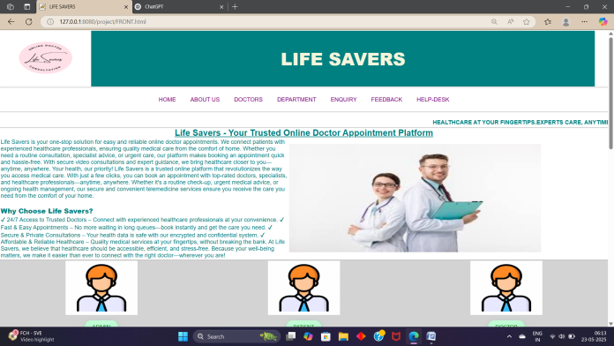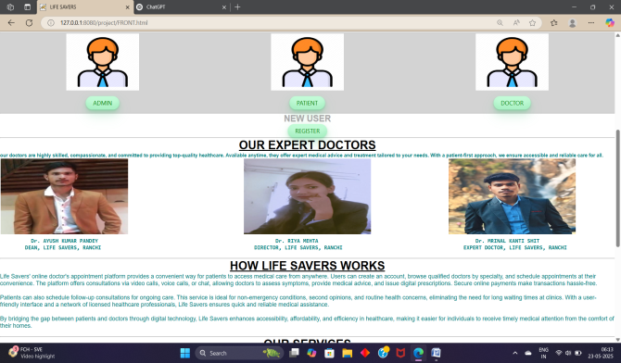

**profile.html**

<!DOCTYPE html>

<HTML>

<HEAD>

<meta charset="UTF-8">

<meta name="viewport" content="width=device-width, initial-scale=1.0">

<style>

.circle-frame {

width: 150px; /* Adjust as needed */

height: 150px; /* Ensure width and height are equal */

border-radius: 50%; /* Makes the image circular */

overflow: hidden; /* Ensures the image stays within the circle */

border: 5px solid teal; /* Optional: Adds a border around the circle */

display: flex;

justify-content: center;

align-items: center;

}

.circle-frame img {

width: 100%;

height: 100%;

object-fit: cover; /* Ensures the image fills the circle without distortion */

}

</style>

<style>

table {

border-collapse: separate;

border-spacing: 0 15px; /* 10px space after each row */

}

</style>

<Title>PROFILE</Title>

</HEAD>

<BODY STYLE="COLOR:teal">

<table>

<tr>

<td><img src="logo.jpg" height="150" width="250"></td>

<td width="1400" bgcolor="teal" style="color:beige"><h1><CENTER><font size=+7><b>LIFE SAVERS</b>

</font></CENTER></h1></td>

</tr>

</table><hr>

<center><div class="circle-frame">

<img src="puchu.jpg" alt="Circular Image">

</div>

<H1>DR. RIYA MEHTA</H1>

<H3>DIRECTOR , LIFE SAVER</H3>

<h3>CONTACT-7667216821</h3>

</center>

<center>

<table font size="+7">

<tr><td WIDTH="300">EDUCTION QUALIFICATION</td><TD>MBBS, MD, MS, DNB ,MHA</TD></tr>

<tr><td WIDTH="300">NAME OF THE INSTITUTE</td><TD>ALL INDIA INTITUTE OF MEDICAL SCIENCE</TD></tr>

<tr><td WIDTH="300">EXPERIENCE</td><TD>15 YEARS EXPERIENCE IN HOSPITAL ADMINISTRATION</TD></tr>

<TR></TR>

<tr><td WIDTH="300">MY KEY SKILLS</td><TD>Leadership, decision-making, and crisis management<BR>

Knowledge of NABH/NABL accreditation, healthcare laws, and ethics<BR>

Strategic planning and patient care advocacy</TD></tr>

<tr><td WIDTH="300">CERTIFICATE</td><TD>Fellowship in Hospital Administration (FHA)<BR>

PG Diploma in Healthcare/Hospital Management </TD></tr>

</table>

<H3>AIM:-"To create a patient-centric, technologically advanced,<BR>

and sustainable healthcare ecosystem that ensures quality, <BR>accessibility, and affordability for all.</H3>

</center>

</BODY>

</html>

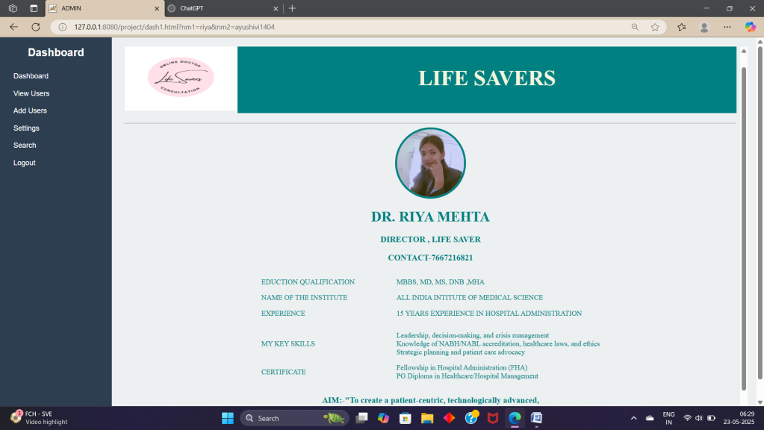

**ADMIN LOGIN(admin.html)**

<!DOCTYPE html>

<html>

<head>

<meta charset="UTF-8">

<meta name="viewport" content="width=device-width, initial-scale=1.0">

<style>

* {

margin: 0;

padding: 0;

box-sizing: border-box;

}

body {

font-family: Arial, sans-serif;

}

.navbar {

background-color:white;

overflow: hidden;

display: flex;

justify-content: center;

padding: 10px 0;

}

.navbar a {

color: purple;

text-decoration: none;

padding: 14px 20px;

transition: 0.3s;

cursor: pointer;

}

.navbar a:hover, .navbar a.active {

background-color: turquoise;

border-radius: 5px;

}

</style>

<script>

document.addEventListener("DOMContentLoaded", function() {

const links = document.querySelectorAll(".navbar a");

links.forEach(link => {

link.addEventListener("click", function() {

links.forEach(l => l.classList.remove("active"));

this.classList.add("active");

});

});

});

</script>

<script language="javascript">

function check()

{

var x,y;

x=frm.nm1.value;

y=frm.nm2.value;

if(x=="" ||y=="")

{

alert("no fields can be blank");

return false;

}

if(x=="riya" && y=="ayushivi1404")

{

alert("correct user");

return true;

}

else

{

alert("Incorrect user");

return false;

}

}

</script>

</head>

<title>

ADMIN LOGIN

</title>

</head>

<BODY>

<CENTER>

<H1> <FONT SIZE=+6>ADMIN LOGIN</FONT></H1><HR><BR><BR>

<head>

<body>

<table>

<tr>

<td><img src="logo.jpg" height="150" width="250"></td>

<td width="1400" bgcolor="teal" style="color:beige"><h1><CENTER><font size=+7><b>LIFE SAVERS</b>

</font></CENTER></h1></td>

</tr>

</table><hr>

<div class="navbar">

<a href="FRONT.html" class="active">HOME</a>

<a href="about.html">ABOUT US</a>

<a href="doctorspage.html">DOCTORS</a>

<a href="department.html">DEPARTMENT</a>

<a href="enquiry.html">ENQUIRY</a>

<a href="feedback.html">FEEDBACK</a>

<a href="help.html">HELP-DESK</a>

</div>

<hr><br>

<form name="frm" onsubmit="return check();" method="get" action="dash1.html">

<b>Enter Name</b><input type="text" name="nm1" size=20><br><br>

Password<input type="password" name="nm2" size=20><br>

<input type="submit" value="submit">

</form></body></html>

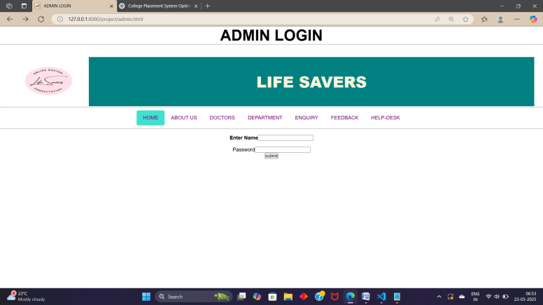

**Patient register.html**

<!DOCTYPE html>

<html>

<head>

<meta charset="UTF-8">

<meta name="viewport" content="width=device-width, initial-scale=1.0">

<style>

* {

margin: 0;

padding: 0;

box-sizing: border-box;

}

body {

font-family: Arial, sans-serif;

}

.navbar {

background-color:white;

overflow: hidden;

display: flex;

justify-content: center;

padding: 10px 0;

}

.navbar a {

color: purple;

text-decoration: none;

padding: 14px 20px;

transition: 0.3s;

cursor: pointer;

}

.navbar a:hover, .navbar a.active {

background-color: turquoise;

border-radius: 5px;

}

</style>

<script>

document.addEventListener("DOMContentLoaded", function() {

const links = document.querySelectorAll(".navbar a");

links.forEach(link => {

link.addEventListener("click", function() {

links.forEach(l => l.classList.remove("active"));

this.classList.add("active");

});

});

});

</script>

<style>

table {

border-collapse: separate;

border-spacing: 0 15px; /* 10px space after each row */

}

</style>

<title>

REGISTRATION FORM

</title>

</head>

<BODY><form action="register.jsp" method="post">

<table>

<tr>

<td><img src="logo.jpg" height="150" width="250"></td>

<td width="1400" bgcolor="teal" style="color:beige"><h1><CENTER><font size=+7><b>LIFE SAVERS</b>

</font></CENTER></h1></td>

</tr>

</table><hr>

<div class="navbar">

<a href="#home" class="active">HOME</a>

<a href="about.html">ABOUT US</a>

<a href="doctorspage.html">DOCTORS</a>

<a href="department.html">DEPARTMENT</a>

<a href="enquiry.html">ENQUIRY</a>

<a href="feedback.html">FEEDBACK</a>

<a href="help.html">HELP-DESK</a>

</div>

<hr><br>

<CENTER>

<H1> <FONT SIZE=+6>REGISTRATION FORM</FONT></H1><HR><BR><BR>

<table>

<tr><td><H4>NAME</H4></td><td><input type ="text" placeholder="Enter name" input size="30" name="nm1"></td></tr>

<tr><td WIDTH="100"><H4>GENDER</H4></td><td><input type="radio" name="nm2" value="male">MALE<input type="radio" name="rd" value="female" name="nm2">FEMALE</td></tr>

<TR><TD><h4>AGE</h4></TD><td><input type="number" placeholder="Enter your age" input size="3" name="nm3"></td></TR>

<tr><td><h4>EMAIL</h4></td><td><input type="text" placeholder="Enter your email" name="nm4"></td></tr>

<tr><td><h4>CONTACT</h4></td><td><input type="number" placeholder="Enter your phone no." input size="20" name="nm5"></td></tr>

<tr><td><h4>ADDRESS</h4></td><td><input type="text" placeholder="Enter your address" input size="50" name="nm6"></td></tr>

<tr><td><h4>STATE</h4></td><td><select name="nm7">

<option>select</option>

<option>Andhra Pradesh</option>

<option>Arunachal Pradesh</option>

<option>Assam</option>

<option>Bihar</option>

<option>Chhattisgarh</option>

<option> Goa</option>

<option>Gujarat</option>

<option>Haryana</option>

<option>Himachal Pradesh</option>

<option>Jharkhand</option>

<option>Karnataka</option>

<option>Kerala</option>

<option>Madhya Pradesh</option>

<option>Maharashtra</option>

<option> Manipur</option>

<option> Meghalaya</option>

<option>Mizoram</option>

<option> Nagaland</option>

<option>Odisha</option>

<option>Punjab</option>

<option> Rajasthan</option>

<option> Sikkim</option>

<option>Tamil Nadu</option>

<option> Telangana</option>

<option> Tripura</option>

<option> Uttar Pradesh</option>

<option> Uttarakhand</option>

<option> West Bengal</option>

</td></tr>

<tr><td><h4>PASSWORD</h4></td><TD><input type="text" placeholder="Enter a password" input size="15" name="nm8"></TD></tr>

<tr><td><h4>CONFIRM PASSWORD</h4></td><td><input type="text" placeholder="Re-enter your password" name="nm9"></td></tr>

<tr><td><center><input type=submit onclick="SUBMIT" value="submit"></center></td></tr>

</table>

</CENTER>

</form>

</BODY>

</html>

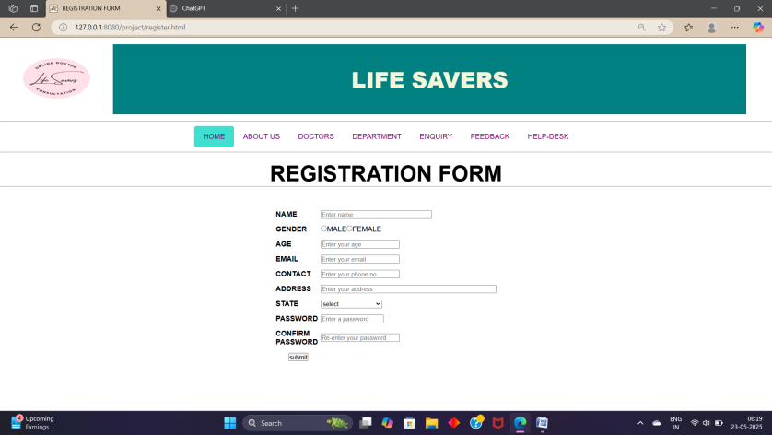

**Doctor registration.html**

<!DOCTYPE html>

<html>

<head>

<meta charset="UTF-8">

<meta name="viewport" content="width=device-width, initial-scale=1.0">

<style>

* {

margin: 0;

padding: 0;

box-sizing: border-box;

}

body {

font-family: Arial, sans-serif;

}

.navbar {

background-color:white;

overflow: hidden;

display: flex;

justify-content: center;

padding: 10px 0;

}

.navbar a {

color: purple;

text-decoration: none;

padding: 14px 20px;

transition: 0.3s;

cursor: pointer;

}

.navbar a:hover, .navbar a.active {

background-color: turquoise;

border-radius: 5px;

}

</style>

<script>

document.addEventListener("DOMContentLoaded", function() {

const links = document.querySelectorAll(".navbar a");

links.forEach(link => {

link.addEventListener("click", function() {

links.forEach(l => l.classList.remove("active"));

this.classList.add("active");

});

});

});

</script>

<style>

table {

border-collapse: separate;

border-spacing: 0 15px; /* 10px space after each row */

}

</style>

<title>

DOCTOR'S REGISTRATION FORM

</title>

</head>

<BODY><form action="doctor registration.jsp" method="post">

<table>

<tr>

<td><img src="logo.jpg" height="150" width="250"></td>

<td width="1400" bgcolor="teal" style="color:beige"><h1><CENTER><font size=+7><b>LIFE SAVERS</b>

</font></CENTER></h1></td>

</tr>

</table><hr>

<div class="navbar">

<a href="FRONT.html" class="active">HOME</a>

<a href="about.html">ABOUT US</a>

<a href="doctorspage.html">DOCTORS</a>

<a href="department.html">DEPARTMENT</a>

<a href="enquiry.html">ENQUIRY</a>

<a href="feedback.html">FEEDBACK</a>

<a href="help.html">HELP-DESK</a>

</div>

<hr><br>

<CENTER>

<H1> <FONT SIZE=+6>DOCTOR'S REGISTRATION FORM</FONT></H1><HR><BR><BR>

<table>

<tr><td><H4>NAME</H4></td><td><input type ="text" placeholder="Enter name" input size="30" name="nm1"></td></tr>

<tr><td WIDTH="100"><H4>GENDER</H4></td><td><input type="radio" name="nm2" value="male">MALE<input type="radio" name="rd" value="female" name="nm2">FEMALE</td></tr>

<TR><TD><h4>AGE</h4></TD><td><input type="number" placeholder="Enter your age" input size="3" name="nm3"></td></TR>

<tr><td><h4>EMAIL</h4></td><td><input type="text" placeholder="Enter your email" name="nm4"></td></tr>

<tr><td><h4>CONTACT</h4></td><td><input type="number" placeholder="Enter your phone no." input size="20" name="nm5"></td></tr>

<tr><td><h4>ADDRESS</h4></td><td><input type="text" placeholder="Enter your address" input size="50" name="nm6"></td></tr>

<tr><td><h4>QUALIFICATION</h4></td><td><input type="text" placeholder="Enter your highest qualificaton" input size=30 name=nm7</td></tr>

<tr><td><h4>NAME OF THE INSTITUTE</h4></td><TD><INPUT TYPE=TEXT placeholder="Name the institute" input size="30" name="nm8"></TD></tr>

<tr><td><h4>SPECIALISATION</h4></td><td><input type="text" placeholder="Any feild SPECIALISATION"name=nm9></td></tr>

<tr><td><h4>WORKING EXPERIENCE</h4></td><td><input type="number" placeholder="if any" name="nm10"></td></tr>

<tr><td><h4>STATE</h4></td><td><select name="nm11">

<option>select</option>

<option>Andhra Pradesh</option>

<option>Arunachal Pradesh</option>

<option>Assam</option>

<option>Bihar</option>

<option>Chhattisgarh</option>

<option> Goa</option>

<option>Gujarat</option>

<option>Haryana</option>

<option>Himachal Pradesh</option>

<option>Jharkhand</option>

<option>Karnataka</option>

<option>Kerala</option>

<option>Madhya Pradesh</option>

<option>Maharashtra </option>

<option> Manipur</option>

<option> Meghalaya</option>

<option>Mizoram</option>

<option> Nagaland</option>

<option>Odisha</option>

<option>Punjab</option>

<option> Rajasthan</option>

<option> Sikkim </option>

<option>Tamil Nadu</option>

<option> Telangana</option>

<option> Tripura</option>

<option> Uttar Pradesh</option>

<option> Uttarakhand</option>

<option> West Bengal</option>

</td></tr>

<tr><td><h4>PASSWORD</h4></td><TD><input type="text" placeholder="Enter a password" input size="15" name="nm12"></TD></tr>

<tr><td><h4>CONFIRM PASSWORD</h4></td><td><input type="text" placeholder="Re-enter your password" name="nm13"></td></tr>

<tr><td><center><input type=submit onclick="SUBMIT" value="submit"></center></td></tr>

</table>

</CENTER>

</form>

</BODY>

</html>

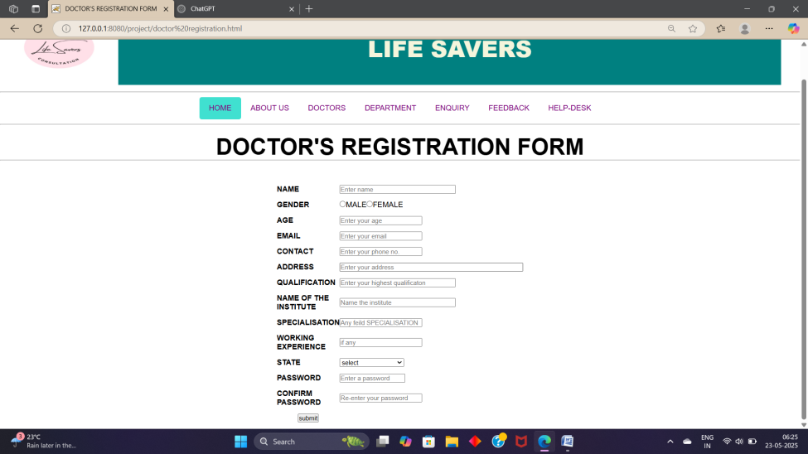

**6.2 Creating Tables in Databases**

**patient table**

Create table patient (Name Varchar(20),gender varchar(30),age varchar(20),email varchar(30),contact varchar(20),address varchar(50),state varchar(20),dob varchar(20),password varchar(10), confirm password varchar(20));

**doctor table**

Create table doctor (Name Varchar(20),gender varchar(30),age varchar(20),email varchar(30),contact varchar(20),address varchar(50),qualification varchar(20),name of institute varchar(30),specification varchar(30), working experience int(10),state varchar(20),dob varchar(20),password varchar(10), confirm password varchar(20));

**6.3 Creating Jsp pages**

doctor

<%@ page language="java" import="java.net.*"%>

<%@ page import="java.io.*"%>

<%@ page import="java.sql.*"%>

<html>

<body>

<%

String s1 = request.getParameter("nm1");

String s2 = request.getParameter("nm2");

String s3 = request.getParameter("nm3");

String s4 = request.getParameter("nm4");

String s5 = request.getParameter("nm5");

String s6 = request.getParameter("nm6");

String s7 = request.getParameter("nm7");

String s8 = request.getParameter("nm8");

String s9 = request.getParameter("nm9");

String s10 = request.getParameter("nm10");

String s11 = request.getParameter("nm11");

String s12 = request.getParameter("nm12");

String s13 = request.getParameter("nm13");

Connection con = null;

Statement s = null;

try

{

Class.forName("oracle.jdbc.driver.OracleDriver");

con = DriverManager.getConnection("jdbc:oracle:thin:@localhost:1521:xe","system","ayushivi1404");

PreparedStatement ps = con.prepareStatement("insert into doctorr values(?,?,?,?,?,?,?,?,?,?,?,?,?)");

ps.setString(1,s1);

ps.setString(2,s2);

ps.setString(3,s3);

ps.setString(4,s4);

ps.setString(5,s5);

ps.setString(6,s6);

ps.setString(7,s7);

ps.setString(8,s8);

ps.setString(9,s9);

ps.setString(10,s10);

ps.setString(11,s11);

ps.setString(12,s12);

ps.setString(13,s13);

ps.executeUpdate();

}

catch(Exception se){out.println(se);}

%>

<p> You have registred succefully</p>

</body>

</html>

Company

<%@ page language="java" import="java.net.*"%>

<%@ page import="java.io.*"%>

<%@ page import="java.sql.*"%>

<html>

<body>

<%

String s1 = request.getParameter("nm1");

String s2 = request.getParameter("nm2");

String s3 = request.getParameter("nm3");

String s4 = request.getParameter("nm4");

String s5 = request.getParameter("nm5");

String s6 = request.getParameter("nm6");

String s7 = request.getParameter("nm7");

String s8 = request.getParameter("nm8");

String s9 = request.getParameter("nm9");

Connection con = null;

Statement s = null;

try

{

Class.forName("oracle.jdbc.driver.OracleDriver");

con = DriverManager.getConnection("jdbc:oracle:thin:@localhost:1521:xe","system","ayushivi1404");

PreparedStatement ps = con.prepareStatement("insert into register values(?,?,?,?,?,?,?,?,?)");

ps.setString(1,s1);

ps.setString(2,s2);

ps.setString(3,s3);

ps.setString(4,s4);

ps.setString(5,s5);

ps.setString(6,s6);

ps.setString(7,s7);

ps.setString(8,s8);

ps.setString(9,s9);

ps.executeUpdate();

}

catch(Exception se){out.println(se);}

%>

<p> You have registred succefully</p>

</body>

</html>

6.4 Final Output

**Home page**





**Patient Registration and Login Page**



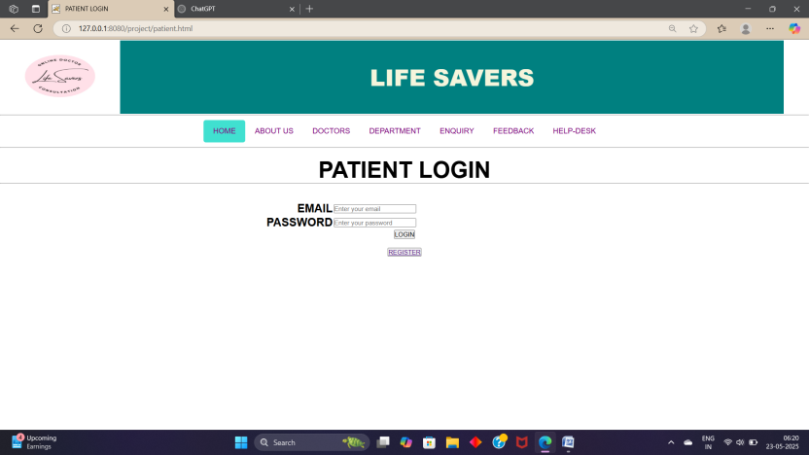

**Doctor Registration and Login Page**



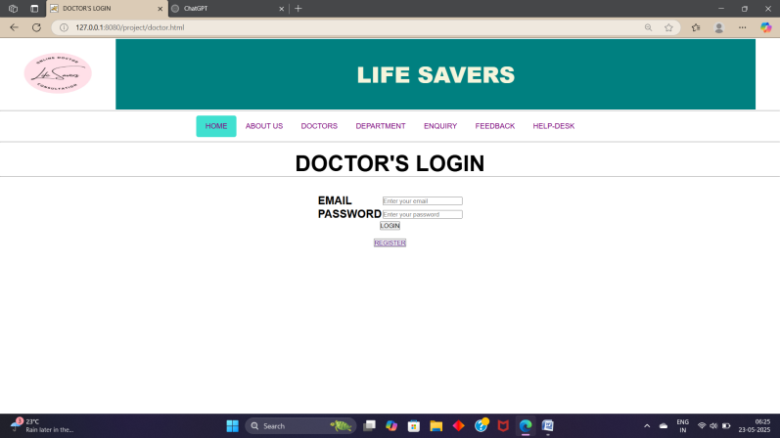

**Admin Login**



**Admin Dash board**



* + 1. **References**

1. **Oracle.** *Java Platform, Standard Edition Documentation.* Available at: <https://docs.oracle.com/javase/>  
   Accessed on: May 2025.
2. **Spring Framework.** *Spring Boot Reference Documentation.* Available at: <https://spring.io/projects/spring-boot>  
   Accessed on: May 2025.
3. **Thymeleaf.** *Thymeleaf: Java XML/XHTML/HTML5 Template Engine.* Available at: <https://www.thymeleaf.org/>  
   Accessed on: May 2025.
4. **Mozilla Developer Network (MDN).** *HTML, CSS, and JavaScript documentation.* Available at: <https://developer.mozilla.org/>  
   Accessed on: May 2025.
5. **MySQL.** *MySQL 8.0 Reference Manual.* Available at: <https://dev.mysql.com/doc/>  
   Accessed on: May 2025.
6. GeeksforGeeks. *Full Stack Web Development Tutorial.* Available at: <https://www.geeksforgeeks.org/full-stack-web-development/>  
   Accessed on: May 2025.
7. **Baeldung.** *Guide to Spring Boot and Full Stack Web Development.* Available at: <https://www.baeldung.com/spring-boot>  
   Accessed on: May 2025.
8. **Stack Overflow.** *Community-driven Q&A for programming and software development.* Available at: <https://stackoverflow.com/>  
   Accessed on: May 2025.